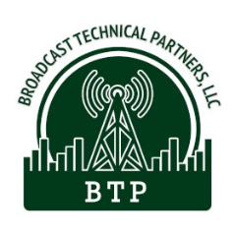Broadcast Technical Partners, LLC

PO Box 5561

Pasco WA 99302

Phone: 509-410-1619

Email: contact@broadcast-technical.com

1/6/2024

Dear Brian Patrick,

Congratulations! Your application has been accepted for filing with the FCC.

Per the FCC you will need to post an Internet Public Notice by January 16, 2024 and leave it posted for 30 days. This can be done on your own church website or an affiliated web site that local citzens might find. If a local news outlet (TV/radio/newspaper) allows free postings you can use that. The link to the announcement should be "conspicuous" (easily visible) on the web page, and should be a separate page containing the text of the announcement.

Below are definitions for alternate web sites:

*(5) Publicly accessible website. An internet website:  
(i) That is accessible to members of the public without registration or payment requirements, or any other requirement that the user provide information, or response to a survey or questionnaire in exchange for being able to access information on the website; and  
(ii) That is locally targeted to the area served and/or to be served by the applicant station (e.g., local government internet website, local community bulletin board internet website, state broadcasters' association internet website).*

The announcement content should look like this:

On December 13, 2023, Calvary’s Grace Baptist Church, applicant for a Noncommercial LPFM Radio Station on 98.7, in Ailey, filed an application with the Federal Communications Commission for a new Noncommercial FM Station. Members of the public wishing to view this application or obtain information about how to file comments and petitions on the application can visit, https://enterpriseefiling.fcc.gov/dataentry/views/public/fmDraftCopy?displayType=html&appKey=25076f918ad38b05018adc48ca1001b6&id=25076f918ad38b05018adc48ca1001b6&goBack=N#sect-chanFacility.

Sincerely,



**Broadcast Technical Partners, LLC**  
cristig@broadcast-technical.com  
https://broadcast-technical.com  
(509)410-1619